Step 1: Click on debug icon and then select ‘Add Configuration’.

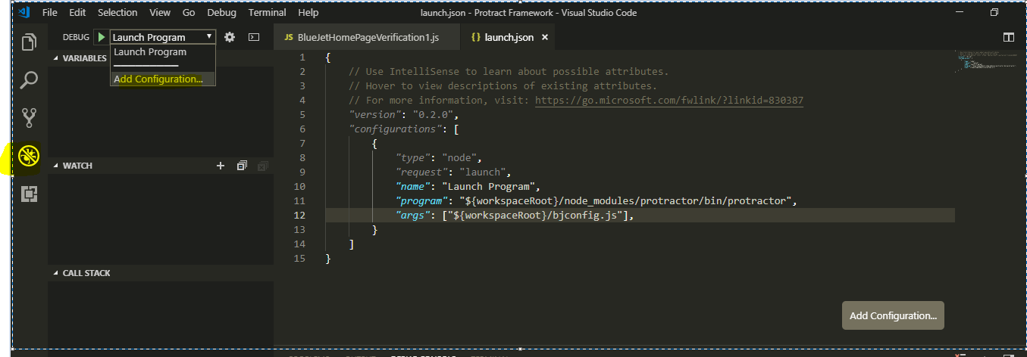

Step 2: After clicking on ‘Add Configuration’, ‘launch.json’ file will be created in project root folder.

Enter the following lines in this file

{

// Use IntelliSense to learn about possible attributes.

// Hover to view descriptions of existing attributes.

// For more information, visit: https://go.microsoft.com/fwlink/?linkid=830387

*"version"*: "0.2.0",

*"configurations"*: [

{

*"type"*: "node",

*"request"*: "launch",

*"name"*: "Launch Program",

*"program"*: "${workspaceRoot}/node_modules/protractor/bin/protractor",

*"args"*: ["${workspaceRoot}/bjconfig.js"],

}

]

}

Note: We have copy the node_modules folder into local project as follow and then need to specify its path into “program” parameters

For ‘args’ parameter we have to provide the configuration file.

bjconfig.js structure is as follow:

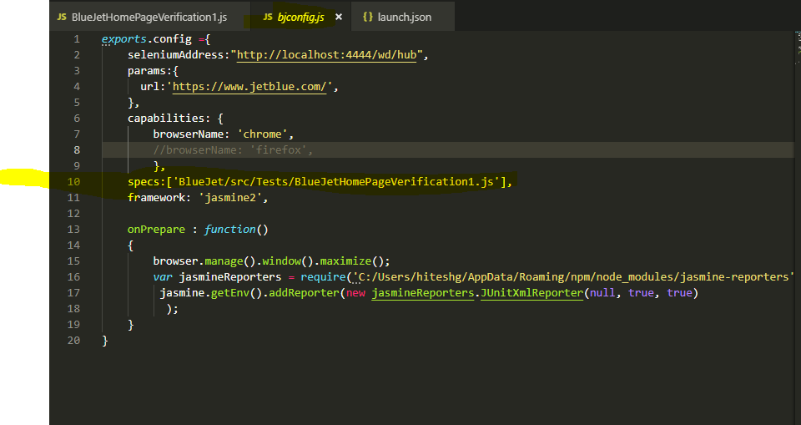

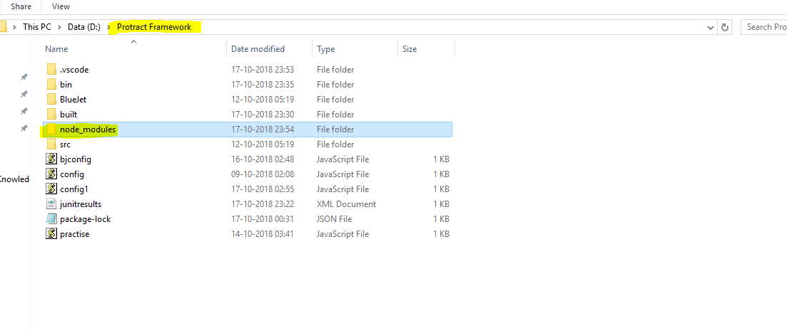

Step 3: Now set a break point as follow:

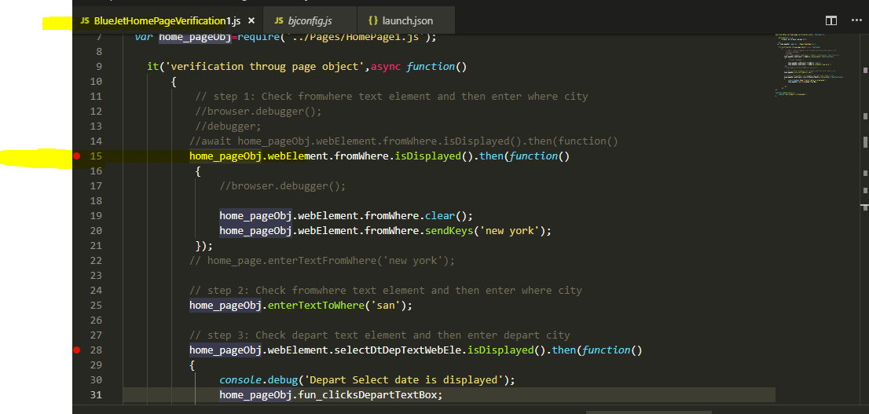

Step 4: Click on play button in debug bar as follow:

